ILMA ERP — Super Admin Portal Blueprint
What you need is an ILMA Super Admin Portal: a central control panel where your team manages every institute using ILMA, from onboarding and access control to subscriptions, billing, expenses, customer support, and product analytics.
My recommendation is to build it as a separate internal management portal connected to your ILMA ERP, not as another screen inside the institute's dashboard. That gives your team central control while keeping each institute's student, parent, teacher, and financial data isolated.
1. The main dashboard
ILMA BY AL-MANTIQ
Super Admin
Customer operations overview

Add to Favorites
Total institutes
All
Registered customers
Active subscriptions
Live
Current customer plans
Outstanding invoices
Due
Payments to follow up
Support & alerts
Live
Issues requiring attention
Concept preview — these are dashboard categories, not live ILMA customer data.
Your actual dashboard should answer five questions immediately:
- How many institutes are using ILMA right now?
- Which customers are active, suspended, on trial, or overdue?
- How much revenue have we collected, and how much is outstanding?
- Which institutes need support or may stop using ILMA?
- What needs action from our team today?
2. Recommended modules for your portal
Here is the structure I would build for ILMA. It is designed around your business: selling an education ERP to schools, academies, colleges, IT institutes, and madrassas.
1. Overview Dashboard
Business KPIs, customer activity, revenue and alerts
2. Institute Management
All customers, campuses, contacts and account status
3. Access & Invitations
Generate invite keys, activate accounts, suspend or revoke access
4. Customer Analytics
Login activity, feature usage, adoption and customer health
5. Subscriptions & Billing
Plans, invoices, renewals, payments and overdue accounts
6. Finance & Expenses
Business expenses, operational costs, profit and cash flow
7. Team & Permissions
Internal staff, roles, access rights and approval controls
8. Support & CRM
Customer tickets, demos, follow-ups and renewal opportunities
9. System Monitoring
Service health, errors, backups and integration status
10. Settings & Audit Logs
Security policies, configuration and a record of admin actions
3. Institute management — your most important module
You should be able to open any institute and manage its entire relationship with ILMA from a single profile.
Each institute should have:
- Basic information: institute name, owner, contact details, country, city, institution type and number of campuses.
- Account status: Lead, Demo Scheduled, Trial, Active, Suspended, Expired or Cancelled.
- Subscription: plan, start date, renewal date, amount, payment history and outstanding balance.
- Access controls: activate, temporarily suspend, revoke access, reset invitations and manage authorized users.
- Usage analytics: active users, last activity, modules used, storage consumption and login history.
- Customer relationship: assigned account manager, demo history, support tickets, notes and follow-up date.
- History: who changed the account, what was changed and when.
For multi-campus customers, distinguish the parent institute from its branches. You should be able to suspend one branch if necessary without accidentally disabling the entire organization.
4. Invitation keys and access management
This deserves a dedicated module rather than a simple generate-key button.
Invite & Access Control
Institute name
Invitation purpose
Free trial access
Paid customer onboarding
Internal staff invitation
Key expires in (days)7 days
Redemption limit1 use
Internal note (optional)
Develop this module specification
Interactive planning example only. This does not generate a real key or change any ILMA account.
The production module should support:
- Random, unguessable invitation tokens, with expiry and redemption limits.
- One-time redemption by default for administrator invitations.
- Manual activation, suspension and immediate revocation.
- Access tied to the correct institute, role and subscription.
- Notifications when invitations are accepted, expire or are revoked.
- Rate limiting and logging to prevent brute-force attempts.
Important: An invitation key must not automatically grant unrestricted administrator privileges. The backend must verify the key, its intended institute, the user's identity and the permissions being granted. Tenant isolation and server-side authorization are foundational safeguards for multi-tenant software.

Ideabat
+1
5. Real-time customer analytics
Don't limit analytics to the total number of registered institutes. You need to understand whether customers are actually using ILMA and getting value from it.
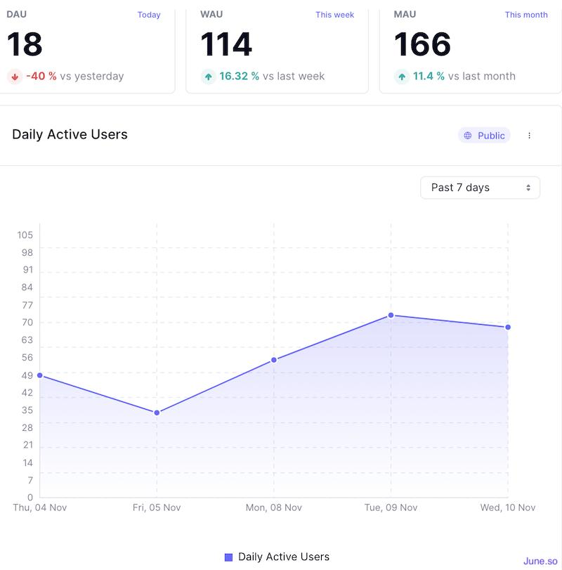
Add to Favorites
Usage and engagement
Daily and monthly active users, active teachers and parents, login frequency, last activity and usage by module.
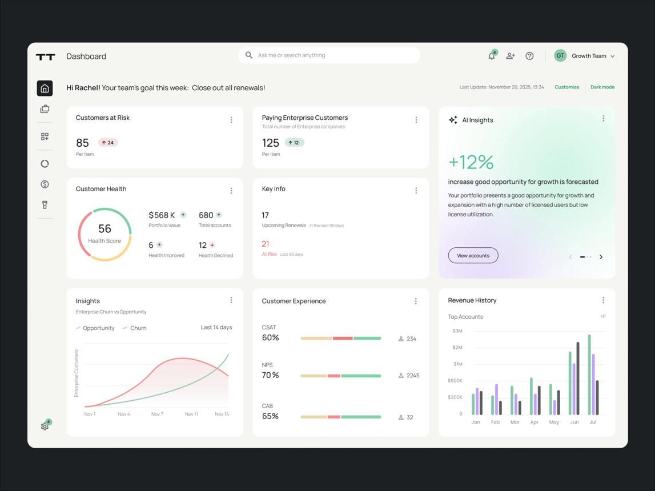
Add to Favorites
Customer health
Institutes with declining activity, onboarding delays, unresolved tickets, upcoming renewals and possible cancellation risks.
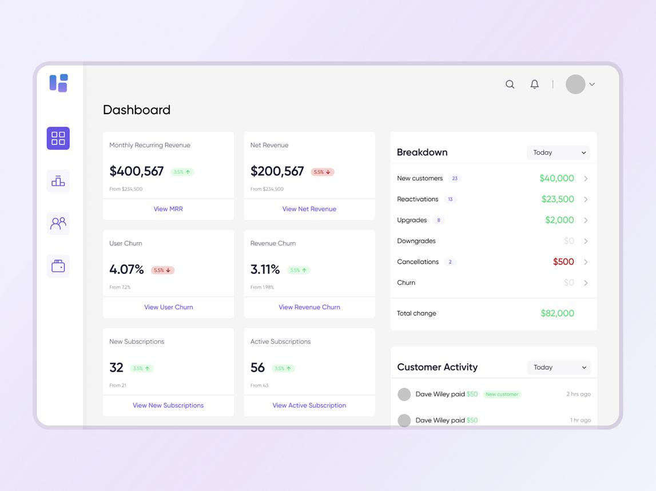
Add to Favorites
Business performance
Monthly recurring revenue, annual recurring revenue, customer acquisition, renewal rate, churn and revenue per institute.
I would also add automated alerts, such as:
- An institute has not logged in for seven days.
- A trial ends in three days.
- A subscription payment is overdue.
- An institute's usage drops sharply compared with its normal activity.
- A customer has an unresolved high-priority support issue.
These should be configurable rules, not arbitrary assumptions. For example, a school may have low activity during holidays, so inactivity alerts should account for academic calendars.
6. Billing, expenses and profitability
Keep billing and internal expenses as separate modules connected to the same financial dashboard.
Billing and revenue | Expenses and costs
Customer invoices | Staff salaries and contractor payments
Subscription payments | Hosting and cloud infrastructure
Outstanding balances | SMS, WhatsApp and email charges
Refunds and credits | AI/API usage costs
Renewals and recurring revenue | Sales, marketing and support costs
Discounts and tax records | Software subscriptions and other overhead
Your dashboard should calculate:
- Collected revenue: money actually received, not merely invoiced.
- Outstanding receivables: amounts customers still owe.
- Recurring revenue: active recurring subscription value, excluding one-off fees.
- Operating expenses: recorded business costs for the selected period.
- Estimated operating profit: recognized revenue minus recorded operating expenses, with the accounting basis clearly defined.
- Customer profitability: revenue per institute compared with its estimated hosting, support and usage costs.
Do not confuse cash collected with revenue earned. Refunds, annual prepayments, unpaid invoices and tax treatment can materially change the numbers. Build the financial reporting around clearly defined accounting rules.
7. Features that will make ILMA much easier to manage
These are the additions I would prioritize beyond your initial requirements.
Feature flags and plan entitlements
Enable or disable individual features for a particular institute, such as AI Copilot, WhatsApp integration, multi-branch reporting or advanced analytics. Control access through the backend, not just by hiding menu items.
Customer support workspace
View issues, assign tickets, set priorities, track response times and maintain a record of conversations.
Demo and sales pipeline
Track prospects from enquiry to demo, trial, conversion and renewal. Include follow-up reminders and the responsible salesperson.
Backup, export and recovery
Monitor backup success, manage customer data exports and test restoration procedures. Make it possible to recover one institute's data without affecting other customers.
Audit trail and controlled support access
Log sensitive actions, including access revocation, subscription changes, refunds, permission updates and support access to a customer account.
Central notification centre
Show payment failures, expiring trials, renewal reminders, integration failures and service incidents in one place.
For support access that lets an employee view an institute's experience, implement time-limited, explicitly authorized access with a visible indication and a complete audit trail. Avoid unrestricted, invisible impersonation.
4Byte Agency
+1
8. Internal staff roles
Not every employee should have full control over every institute and financial record.
Role | Suggested permissions
Super Admin | All administrative functions, with sensitive actions logged
Operations Manager | Institutes, onboarding, access and operational settings
Sales Team | Leads, demos, trials and customer follow-ups
Finance Manager | Invoices, payments, expenses and financial reports
Customer Support | Assigned tickets and authorized customer diagnostics
Analyst | Read-only analytics and approved exports
Technical Admin | System health, deployments and technical operations
Use role-based permissions, multi-factor authentication, and approval requirements for high-impact actions. For example, a staff member might prepare a refund while a finance manager approves it.
9. What I would build first
Do not attempt to build every module simultaneously. Start with the controls needed to operate safely, then add business intelligence and automation.
1
Phase 1 — Core control
First priority
Secure admin login, institute registry, access control, invite keys, subscription status, staff permissions and audit logs.
2
Phase 2 — Commercial operations
Plans, invoices, payments, renewals, expense records, demo pipeline and customer support.
3
Phase 3 — Analytics and automation
Live usage metrics, customer health scoring, churn alerts, profitability reports, scheduled summaries and integrations.
The technical architecture matters as much as the feature list. ILMA should enforce customer data isolation at the database and backend levels, maintain a reliable audit trail, and keep the internal Super Admin permissions separate from customer-facing institute administration.

RAITHub
+2
10. Let's tailor the portal to your existing ILMA ERP
Before choosing the implementation approach, I need one key detail: what technology is your current ILMA ERP built with?
Current ERP technology
Custom-developed application (React, Next.js, Laravel, Django, etc.)
Built using a no-code or low-code platform
Existing ERP software that we customize
I'm not sure about the technology
Hosting setup
Cloud-hosted with a shared database for institutes
Each institute has its own database or deployment
Not sure / not decided
How do customers pay today?
Manually, through bank transfers or other payments
Through an online payment gateway
Billing and subscriptions are not implemented yet
Create my ILMA implementation plan
Once this is clear, the next step is to turn this blueprint into a proper development specification with database structure, permissions, screen-by-screen requirements and integration points, rather than building a disconnected dashboard that cannot reliably control the actual ERP.

